**KUBERENETES REQUIRED DOCUMENTATION**

For hands-on purpose, just install minikube and enable the Kubernetes in docker app.

https://minikube.sigs.k8s.io/docs/start/?arch=%2Fwindows%2Fx86-64%2Fstable%2F.exe+download

Just open terminal and run **minikube start,** make sure that docker is running and enabled k8s.

Check by running **kubectl get pods** the response should be no resource found.

Now to create a **POD,** just run

* **kubectl run my-pod –image nginx**

Now pod will be created.

1. What is pod?

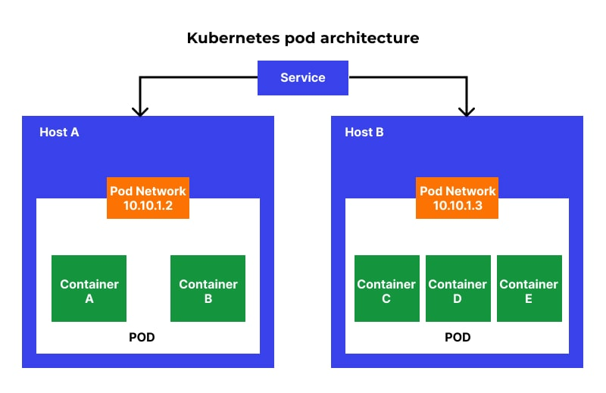

A pod is the smallest execution unit in Kubernetes. A pod encapsulates one or more applications.

Cluster = have multiple containers and we will access the clusterIP. We don’t directly deal with one container because we want high availability and these clusterIP pick any container available and will give data/application.

|  |  |  |  |  |  |  |  |  |  |  |  |  |  |  |  |
| --- | --- | --- | --- | --- | --- | --- | --- | --- | --- | --- | --- | --- | --- | --- | --- |
| |  |  |  |  |  | | --- | --- | --- | --- | --- | | Server/container |  | container |  | container |  |  |  |  |  |  | | --- | --- | --- | --- | --- | | Server/container |  | container |  | container |  |  |  |  |  |  | | --- | --- | --- | --- | --- | | Server/container |  | container |  | container | |

To create POD

apiVersion: v1

kind: Pod

metadata:

name: my-pod

spec:

containers:

* name: my-container

image: nginx